#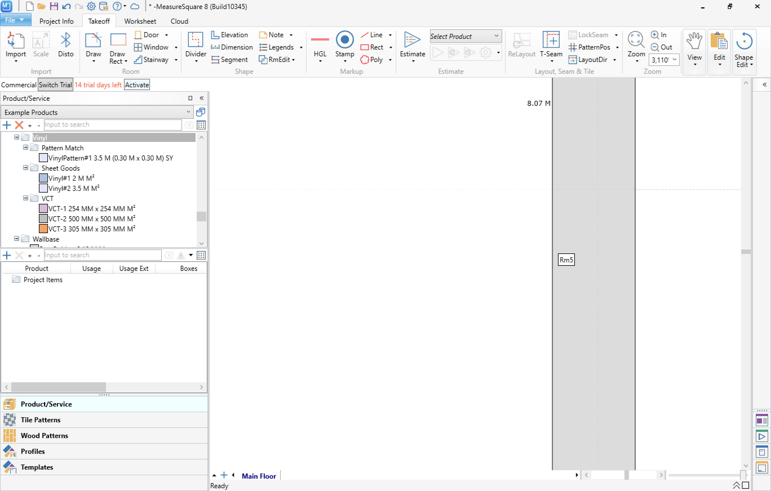

Floor planner updates. Create two vinyl colours to fill in the polygon:  
Vinyl #1 2 M M2 colour is #B0C4DE  
Vinyl #2 3.5M M2 colour is #E6E6FA  
  
Next to the calculate vinyl button add these as a check box choice.

The choice will be the polygon fill colour  
  
When some hits the “D” key or clickd on the Door button a form modal comes up:

Variables: Name the Door input box  
Door width default 0.90 metre  
Open In (means when the door is placed the default is that the door is shown to open inwards on the floor plan  
Checkbox Ignore Door Area – Default not to ignoreNo   
Add another input box of Door that defaults to 0.35 M that adds the polygon vinyl measurement by that amount  
  
Added to current form  
Add Strip Y/N  
Then a drop down for door strip and have default Option 1, Option 2, Option 3 and Option 4. (this adds a strip to the to the distance of the floor of the door  
  
The doors to choose from are:  
Common (refer door.png in /library)  
NoLeaf (refer noleaf.png in /library)  
French (refer french.png in /library)  
Sliding (refer sliding.png in /library)  
Folding (refer folding.png in /library)  
DoubleFolding (refer doublefolding.png in /library)  
When they click close door use:  
ClosedDoor (refer closeddoor.png in /library)  
  
  
Pocket (refer pocket.png in /library)  
  
Add the ability to rotate the doors at 90 degrees. Once a door is placed you must have the ability to drag the door along the polygon wall as you drag you must be able to show far from both ends of the two data points you are away to position the door correctly. So as you drag the door or a window there are two arrow points from the nearest polygon ends changing in distance as you move the object along for both the door and windows. You can drag these object around the whole polygon until you decide to release the mouse button. When dragging the object the object must then rotate if it need to to be perpendicular to the current polygon line.  
  
In the menu area there is an add / remove coping. When add is click you can select a wall in the polygon and add coping (this adds extra length to the size of the polygon for the default for the input field is 0.30 M but can be edited for each individual wall.

Make sure the export polygon function labels location of doors and windows and make sure it adds the size with the coping to the polygon dimensions.  
  
The select does not work have a select then the ability to delete any item that is selected by hitting the delete key.